**Original Research Paper**

[](http://crossmark.crossref.org/dialog/?doi=10.12928/adilj.xxxx&domain=pdf)The title is written in Garamond (18 pt) and preferably not more than 16 words

Name of 1st author a,1, Name of 2nd author b,2, Name of 3rd author c,3

a First affiliation, City, Country (9pt)

b Second affiliation, City, Country (9pt)

c Third affiliation, City, Country (9pt)

1 Email First Author ; 2 Email Second Author; 3 Email Third Author (9pt)

* corresponding author email

Submitted: December 27, 2022 | Revised: May 09, 2023 | Accepted: May 22, 2023

ABSTRACT

The abstract is written in English. Garamond (10,5 pt, line spacing 1, 6 pt after paragraph) preferably between 200-300 words. The abstract should be clear, concise, and descriptive. This abstract should provide a brief introduction to the problem objective of the paper, followed by a statement regarding the methodology if the manuscript is taken from a research report and a brief summary of the results.

**Keywords:** Write 3-5 keywords that reflect the substance of this paper and separate them with commas (,)

[https://licensebuttons.net/l/by-sa/3.0/88x31.png](http://creativecommons.org/licenses/by-sa/4.0/)This is an Open-Access article distributed under the CC-BY-SA license

INTRODUCTION

The introduction (Garamond 12 pt, line spacing 1.15, 6 pt after paragraph) should be clear and provide for the issue to be discussed in the manuscript. Before the objective, authors should provide an adequate background and a very short literature survey in order to record the existing conditions, to show which is the best of previous research, to show the main limitation of the previous research, to show what you want to achieve (to solve the limitation), and to show the scientific merit or novelties of the paper. At the end of the paragraph, the author/s should end with a comment on the significance concerning the identification of the issue and objective of the research. Citation in the main text should be written in the Canadian Guide to Uniform Legal Citation 9th Edition (McGill Guide). Citation examples from journals (Denisova-Schmidt, 2018), books (Tamanaha, 1999), book chapters (Sulaiman et al., 2019), the World Wide Web (Mattar, 2022), law, newspapers (Macfarlane et al., 2014), thesis, and report (Chapman & Lindner, 2016).

METHODS

The method is optional for the original research paper. This method is written in descriptive and should provide a statement regarding the methodology of the research. This method, as much as possible, gives an idea to the reader.

RESULTS AND DISCUSSION

This section is the most important section of your article. The analysis or results of the research should be clear and concise. The results should summarize (scientific) findings rather than provide data in great detail. Please highlight differences between your results or findings and the previous publications by other researchers. For tables and Figures, you need to sound the table and figure.

1. Table’s title

| Table Head | Table Column Head | | |
| --- | --- | --- | --- |
| Table column subhead | Subhead | Subhead |
| copy | More table copy a |  |  |

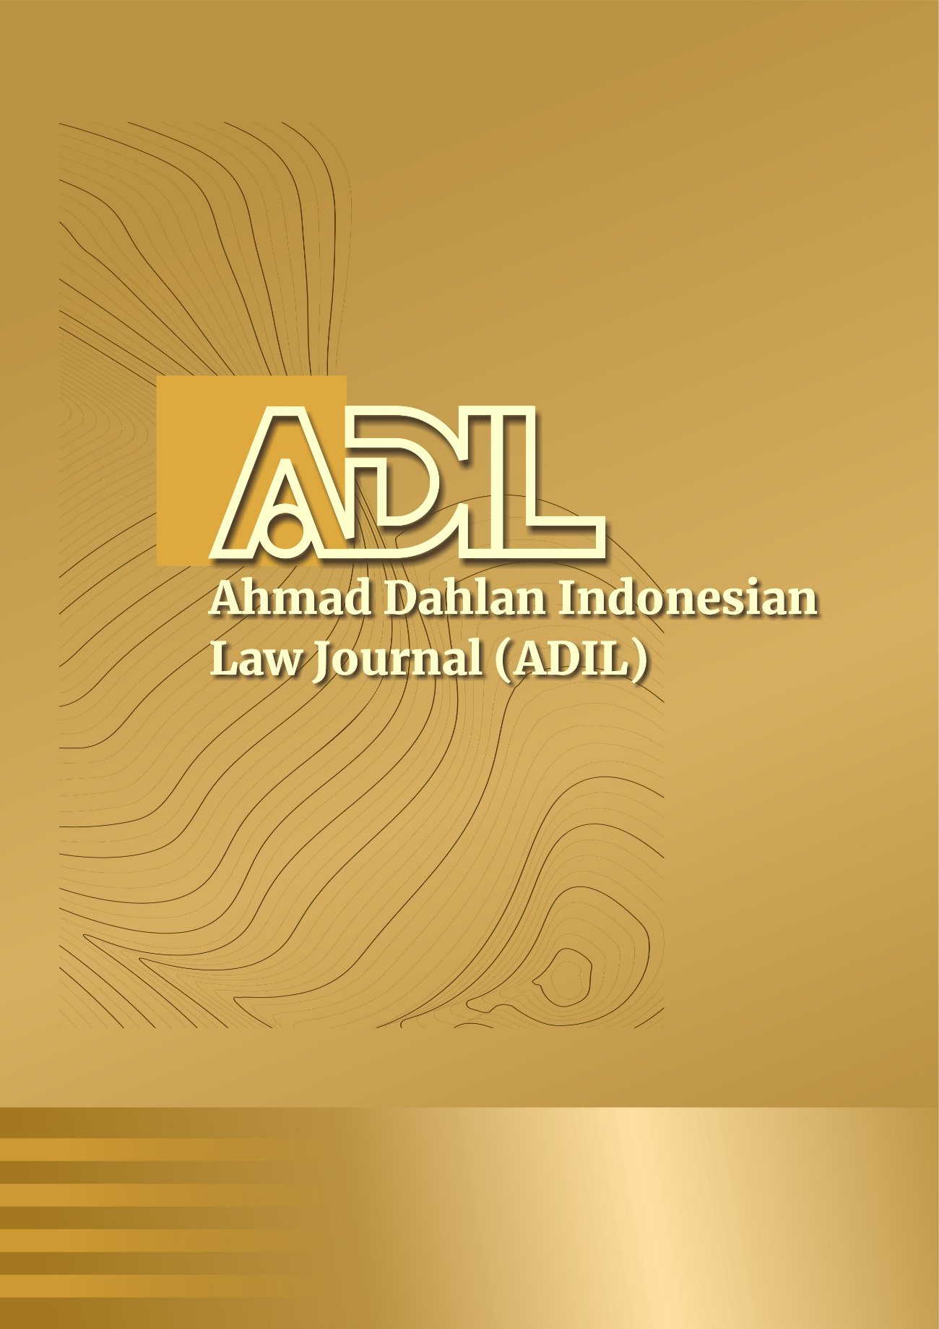

1. Figure’s title

For direct citation, when it is more than four lines, you need to write it in italics (11 pt with single space and 6 pt after paragraph).

“The right to life, the right to not to be tortured, the right to freedom of the individual, to freedom of thought and conscience, the right not to be enslaved, the right to be acknowledged as an individual before the law, and the right not to be prosecuted retroactively under the law are human rights that cannot be diminished under any circumstances whatsoever.”

Sub Section 1

Lorem ipsum dolor sit amet, consectetur adipiscing elit, sed do eiusmod tempor incididunt ut labore et dolore magna aliqua. Ut enim ad minim veniam, quis nostrud exercitation ullamco laboris nisi ut aliquip ex ea commodo consequat. Duis aute irure dolor in reprehenderit in voluptate velit esse cillum dolore eu fugiat nulla pariatur. Excepteur sint occaecat cupidatat non proident, sunt in culpa qui officia deserunt mollit anim id est laborum.

Sub-sub section 2

Lorem ipsum dolor sit amet, consectetur adipiscing elit, sed do eiusmod tempor incididunt ut labore et dolore magna aliqua. Ut enim ad minim veniam, quis nostrud exercitation ullamco laboris nisi ut aliquip ex ea commodo consequat. Duis aute irure dolor in reprehenderit in voluptate velit esse cillum dolore eu fugiat nulla pariatur. Excepteur sint occaecat cupidatat non proident, sunt in culpa qui officia deserunt mollit anim id est laborum.

CONCLUSION

The conclusion contains a description that should answer the problem(s) raised and answer the objectives of the research. Provide a clear and concise conclusion. Do not repeat the Abstract or simply describe the results of the research. Give a clear explanation regarding the possible application and/or suggestions related to the research findings.

ACKNOWLEDGMENT

The preferred spelling of the word “acknowledgment” in America is without an “e” after the “g.” Avoid the stilted expression “one of us (R. B. G.) thanks ...”. Instead, try “R. B. G. thanks...”. Put sponsor acknowledgments in the unnumbered footnote on the first page.

AUTHORS’ DECLARATION

|  |  |  |
| --- | --- | --- |
| **Author contribution** | **:** | The authors made substantial contributions to the conception and design of the study. The authors took responsibility for data analysis, interpretation, and discussion of results. The authors read and approved the final manuscript. |
| **Funding statement** | **:** | None of the authors have received any funding or grants from any institution or funding body for the research. |
| **Availability of data and materials** | **:** | All data are available from the authors. |
| **Conflict of interest** | **:** | The authors declare no conflict of interest. |
| **Additional information** | **:** | No additional information is available for this paper |

REFERENCES

Chapman, D. W., & Lindner, S. (2016). Degrees of integrity: the threat of corruption in higher education. *Studies in Higher Education*, *41*(2), 247–268. https://doi.org/10.1080/03075079.2014.927854

Denisova-schmidt, E. (2018). Corruption, the Lack of Academic Integrity and Other Ethical Issues in Higher Education: What Can Be Done Within the Bologna Process? In *European Higher Education Area: The Impact of Past and Future Policies*. Springer International Publishing. https://doi.org/10.1007/978-3-319-77407-7

Macfarlane, B., Zhang, J., & Pun, A. (2014). Academic integrity: a review of the literature. *Studies in Higher Education*, *39*(2), 339–358. https://doi.org/10.1080/03075079.2012.709495

Mattar, M. Y. (2022). Combating Academic Corruption and Enhancing Academic Integrity through International Accreditation Standards: The Model of Qatar University. *Journal of Academic Ethics*, *20*(2), 119–146. https://doi.org/10.1007/s10805-021-09392-7

Sulaiman, S., Hasan, A., Mohd Noor, A., Ismail, M. I., & Noordin, N. H. (2019). Proposed models for unit trust waqf and the parameters for their application. *ISRA International Journal of Islamic Finance*, *11*(1), 62–81. https://doi.org/10.1108/IJIF-02-2018-0019

Tamanaha, B. Z. (1999). Realistic Socio-Legal Theory: Pragmatism and a Social Theory of Law. In *Oxford Socio-Legal Studies*. Oxford University Press. https://doi.org/10.1093/acprof:oso/9780198298250.001.0001